**Wild-Ireland – Wildlife application that teaches through a first-person game.**

**TU857**

**BSc in Computer Science (Infrastructure)**

**Jake Bolger**

**C18395341**

**Tanya Thompson**

**School of Computer Science**

**Technological University Dublin**

**Date**

**Abstract**

Nowadays, it is difficult to teach students about wildlife by only using textbooks. This project attempts to create a game environment that uses procedural generation, to allow students to view information and give them a new learning experience. This project uses realistic environments, animal AI, wildlife, and testing features to learn about Irish wildlife in a new and creative way. It focuses on wildlife behaviour and giving the user the right information to learn.

**Declaration**

I hereby declare that the work described in this dissertation is, except where otherwise stated, entirely my own work and has not been submitted as an exercise for a degree at this or any other university.

Signed:

_________________________

Jake Bolger

Date

**Acknowledgements**

**Blah, Blah, thankyou, thankyou.**

**Table of Contents**

Table of Contents

Abstract 2

Declaration 3

1. Introduction 7

1.1. Project Background 7

1.2. Project Description 7

1.3. Project Aims and Objectives 7

1.4. Project Scope 7

1.5. Thesis Roadmap 7

2. Literature Review 8

2.1. Introduction 8

2.2. Alternative Existing Solutions to Your Problem 8

2.3. Technologies you’ve researched 8

2.4. Other Research you’ve done 8

2.5. Existing Final Year Projects 8

2.6. Conclusions 8

3. Prototype Design 9

3.1 Introduction 9

3.2. Software Methodology 9

3.3. Overview of System 9

3.4. Front-End 9

3.5. Middle-Tier 9

3.6. Back-End 9

3.7. Conclusions 9

4. Prototype Development 10

4.1. Introduction 10

4.2. Prototype Development 10

4.3. Front-End 10

4.4. Middle-Tier 10

4.5. Back-End 10

4.6. Conclusions 10

5. Testing and Evaluation 11

5.1. Introduction 11

5.2. Plan for Testing 11

5.3. Plan for Evaluation 11

5.5. Conclusions 11

6. Issues and Future Work 12

6.1. Introduction 12

6.2. Issues and Risks 12

6.3. Plans and Future Work 12

6.3.1. GANTT Chart 12

Bibliography 13

1. **Introduction**

**1.1. Project background**

Teaching students in schools and colleges about certain topics can take a boring and uninstructive approach. Many people recall finding it challenging to concentrate and learn information whilst reading from textbooks and lecture slides. Although students can learn this way, only reading from textbooks and lecture slides fails to create an engaging and interactive way for the students to learn. for many students it makes it harder to concentrate for long periods of time.

This project uses 3D modelling, AI, and educational techniques to develop and create an interactive experience that keeps the user engaged in what they are learning about. Using AI to create realistic wildlife behaviours and using quizzes to test the user on the information provided, this system gives the user another option to choose from when learning about wildlife in Ireland.

The use of procedural generation allows the user to experience an immersive environment to explore and discover various wildlife.

**1.2. Project Description \*\*\***

The main goal of this project is to be used as an educational tool to teach students about wildlife in Ireland and improve their knowledge of the various species of plants and animals. I plan to accomplish this by creating a 3D game in unity that allows kids to have a more interactive and enjoyable learning experience which facilitates the way students learn about Irish wildlife.

This Game will allow the user to move freely throughout a procedurally generated landscape which consists of real Irish wildlife such as plants, trees and common species of animals. The player will be able to move with a first person view of the environment and they will be able to explore the terrain as they please. Upon finding different wildlife they will be able to inspect the wildlife and gather information and learn through the game.

Models and assets for rural landscapes will be obtained by scanning real life objects from Irish landscapes.

The animals in this game will use machine learning and AI to maneuver and interact with their surrounding environment and will also be placed procedurally throughout the environment. The Animals will also react to the player using AI.

Once the player has gathered info about a certain life form which will consist of videos, pictures, and text. They will be able to store this information in a virtual journal which they will be able to view throughout the game. Quizzes will be available to the user who wish to test their knowledge on what they have learnt.

Sometimes learning through textbooks can be boring and hard to attract the attention of students.

The idea is that the students will be able to access this game by downloading it through the internet. I plan to launch this project and hopefully it will be used in primary schools and educational institutions all throughout Ireland.

**1.3. Project Aims and Objectives**

The main aim of this project is to provide a game that helps students learn in an engaging way that doesn’t just focusing on learning from textbooks and PowerPoint slides.

To reach the objectives of this system, goals were set and are as follows:

* Conduct thorough research and review literature relevant to this project.
* Compared similar systems to this project.
* Choose suitable design methodologies and create prototypes.
* Create a procedural environment using procedural coding techniques.
* Design and create wildlife with realistic behaviours.
* Use educational techniques to create quizzes for a learning experience.
* Create and design interfaces that are simple to use.
* Test and evaluate the system by using suitable testing methods.
* Once the process is complete, review and reflect on the system using user feedback.

**1.4. Project Scope ***what its not about**

Wildlife will allow the user to explore outdoor terrains within the game which will be full of Irish wildlife. They will be able to do this through first person movement and they will be able to find and inspect different animals and plants in the game. By inspecting them the user will get access to information about the desired object they are looking at such as videos, images, and text.

The user will be able to create and start a new environment whenever they please. These environments will be randomly generated by the game. There will be terrains/environments the user will be able to generate, the first one will be a rural terrain based off something you would have in Ireland with wildlife and animals to suit.

When exploring these terrains, the user will have access to a virtual notebook/diary. Upon finding wildlife and inspecting it, the info collected will be added to their virtual notebook. This will allow the user to have access to the information whenever they please. In this notebook feature the user will be allowed to start a quiz based on the wildlife information they have collected.

All the wildlife in the game will be either animated or use AI to function (sometimes both) and move throughout the map.

**1.5. Thesis Roadmap**

**1.5.1. Literature Review**

This chapter discusses all the relevant background information and research that was completed for this project. Firstly, it looks at the similar systems to this project that have already been created. It then shows the research done into the different technologies that could be used such as games engines, programming languages, database tools, script editors and 3D modelling software. It then goes on to discuss other research such as AI, animation, audio, and assets. Lastly, it goes on to discuss final year projects and academic papers. All this research is described, compared, and decided upon.

**1.5.2. Design**

For this section, the design approach of the system is discussed which will be used to help develop the system. It discusses version control, software methodology and an overview of the system. It then goes on to talk about requirements, UI design techniques, prototypes, use cases, database, and the overall system design.

**1.5.3. Development**

This section discusses the development process that has been undertaken to create this system using the architecture presented in the design section. It then goes on to talk about issues in development.

**1.5.4. Testing and Evaluation**

This section outlines the testing and evaluating done on the project. It talks about the different testing methods used throughout the game such as white and black box testing and discusses in detail the feedback acquired from third-party users.

**1.5.5. Conclusions and Future Work**

This section will discuss and reflect on the system that was created. It will discuss the conclusions in detail, the issues and risks that came along with it and the plans for future work in this system. A GANTT chart will be used to complete this part of the project.

**2. Literature Review**

**2.1. Introduction**

This section looks at, researches, and considers all the different technologies associated to this project. It looks at alternative solutions, programming languages, script editors, render pipelines, modelling software, database tools and various applications.

It also looks at other research such as AI and education in games, whilst also focusing on other techniques to be used such as animation, audio, and Unity Timeline for cutscenes.

Finally, it discusses existing final year projects and academic papers based on this topic.

**2.2. Alternative Existing Solutions to Your Problem**

On a variety of platforms such as Steam, PS Plus and Xbox games – Microsoft Store, there are existing wildlife games that provide educational experiences to their users.

The following applications are games that provide these experiences.

**2.2.1. Beyond Blue**

Beyond Blue is an educational narrative underwater diving game that allows the user to explore the ocean and published by an American studio called E-Line Media. This game was researched because many of its features share similar aspects to this project, such as interactive animal AI and educational information about wildlife.

This game’s features are as follows:

* Interactive ocean allowing tracking of sea creatures.
* Narrative Experience for educational purposes.
* Unique soundtrack.
* Educational mini documentaries.
* Photo mode to allow for pictures.
* Interactive AI animals.
* Animal Collection.

Beyond Blue as a game has many **advantages,** they are as follows:

* It’s a good representation of how a game can make learning very interesting for a user.
* It creates an interactive experience that supplies a lot of valuable information about wildlife.
* Allows the user to gather this information by interacting with animal AI throughout the game.
* This game is available on a variety of platforms for example, Steam, Apple Arcade, PlayStation 4 and Xbox One and comes at a price of €16,79.

**Disadvantages:**

* Although this game has many rich features it does not explore the aspect of quizzes.
* It’s main purpose isn’t for the user to learn the information being presented.



**Figure1-Beyond Blue**



**Figure2-Beyond Blue**

**2.2.2. The Hunter: Call of the Wild**

This game is an immersive hunting game published by Expansive Worlds and Avalanche Studios. The main purpose of this game is hunting. Although the main purpose of this game is not educational it does teach the user how to hunt and it shares a lot of the main features and concepts of my project such as World exploration, animal AI and learning.

This game’s features are as follows:

* World exploration / Open world.
* Animal AI.
* Complex animal behaviour.
* Weather events.
* Day and night cycles.
* Use of guns
* Learn how to hunt.

Call of the Wild is a high-quality game, and its **advantages** are listed below:

* Good example of how an open world game can work.
* Good example of how one could implement animals using AI into a game.
* The hunting feature demonstrates how the user can be taught information on different animals.

**Disadvantages:**

* However, this game isn’t very educational.
* Has no methods of letting the user practice the knowledge they have learnt.



**Figure3-The Hunter: Call of the Wild**



**Figure4-The Hunter: Call of the Wild**

**2.2.3. Zoo Tycoon**

Zoo Tycoon is an educational game that simulates a zoo. The main purpose of this game is to build a zoo and learn about the various animals inside. This game is efficient at teaching children about different species of animals. This game is good in relation to the educational aspect of this project as it allows the user to collect species of animals and learn about them via a journal.

Published by Microsoft Corporation, this game’s features are as follows:

* 200 animals.
* Create custom zoo.
* Collect species.
* Educational information (“zoopedia”)
* Animal AI.

**Advantages:**

* Zoo Tycoon is a good example of an educational game for children.
* It creates an interactive gameplay environment which allows users to build and learn about animals whilst having an enjoyable experience.
* A feature that was very relevant to my project was the “zoopedia”. This allowed the user to press a button and view their “zoopedia” which gave them information about the animals.

**Disadvantages:**

* This game had no testing feature such as quizzes so the user could test their knowledge.
* This seems to be a reoccurring theme with educational games.



**Figure5-Zoo Tycoon**



**Figure6-Zoo Tycoon**

**2.3. Technologies you’ve researched**

In this section, multiple technologies that may be used in this project will be discussed. The most viable options that were considered will be discussed and the main advantages and disadvantages will be researched. Finally, an explanation of what technologies were chosen will be provided along with the technologies that weren’t chosen.

**2.3.1 Games Engines**

A game engine is a software tool that is used to design, develop, and create video games. There are lots of different games engine available but only one will be chosen to use on this project.

Below are the games engines that were researched at and considered to use:

* **Unreal Engine**
* **CryEngine**
* **Armory**
* **Unity**

**Unreal Engine:**

Unreal engine is one of the most advanced and open 3D games engine tools. This engine was developed by epic games and first released in 1988. Unreal engine 4 can be downloaded free and has been used to create a variety of big games such as “Gears of War”, “borderlands” and the “Batman” games.

**Advantages:**

* This engine provides stunning and workable graphics.
* Its user interface is constantly being updated with the latest tools
* It can enable a user to create games without writing scripts.
* It uses the programming language C++ which is generally the best option for most game developers.

**Disadvantages:**

* When trying to make simple games, Unreal Engine is not the best choice.
* Unreal engine is only suitable for larger teams of people to work on and projects that are long-term.
* This engine is hard to learn so for developers just starting out it us not suitable.
* The engine also requires the user to pay a 5% tax once the game is profitable.

In relation to this project, the learning curve for this engine might not be suitable for a project of its size and it is not suitable for small projects.



**Figure7-Unreal Engine 4**

**CryEngine:**

CryEngine is a game engine designed by a company called Crytek. This engine was used to create all the “Far Cry” games. This engine is free to use and was initially released in 2002.

**Advantages:**

* Support for VR
* Very little programming required
* Easy to learn for someone to learn.
* Has good support and its graphics capabilities are quite good.

**Disadvantages:**

* CryEngine’s userbase is quite small.
* There are fewer ways to find help when using it.
* It is not suitable for small development teams or projects.

In relation to this project, although its easy to use, it is not suited to a small project like this.



**Figure8-CryEngine**

**Armory:**

Armory is a 3D Engine that is open source and provides a full Blender add-on. It’s written in the HAXE programming language. Games created in this engine are “Offroad Mania”, “Ghost Rush” and “Xpedition”.

Advantages of Armory are:

* Armory is an Open-Source engine.
* This engine provides good Flexibility.
* Logic Nodes make a visual way of creating interactive behaviour.
* The coding for this engine it quite easy compared to other engines.
* This engine provides a Blender add-on.

Disadvantages are:

* This engine is not even fully developed.
* The user base for this engine is very small providing low support.

In relation to this project the blender add on would be a good advantage but the engine is not finished.



**Figure9-Armory**

**Unity:**

Unity is a game engine developed by Unity Technologies. It was released in 2005. It is cross-platform and is free to download and use. This engine is very popular and has lots of big games that have been created using it. “Cuphead”, “Escape from Tarkov” and “The Forest” were all created in Unity.

Unity Advantages are:

* Its Free to use.
* There is a huge Community support for Unity.
* Unity is well known for being suitable for small teams.
* Interface is easy to learn.
* Uses C#. This language has tons of support and is easy to learn.
* Asset store. This provides lots of free assets to be used in games, such as models, objects, code.

Disadvantages are:

* Graphics aren’t as good as other engines
* Not suitable for AAA games.

In relation to this project its perfect for small teams like this, its got a lot of support so if there are issues they can be resolved easier.



**Figure10-Unity**

**Decision**

The games engine “Unity” was chosen. The main reason for this is that my project is a one-man game which Unity is very suitable for. Unity has great community support with lots of information online about it which will be helpful when creating this game. It also uses C# which I already have experience in.

The reason for not choosing any of the other engines listed is because they all have bigger learning curves and are not suitable for small teams such as one person. There is very little support for some of them which I will need in the future.

**2.3.2. Programming Languages**

In Unity, to use many of this engine’s features, scripts need to be written using a programming language and used to give it instructions to create games. there are a few different languages that I have researched and considered.

**The languages are as follows:** C#, JavaScript / UnityScript, Boo, IronPython, MoonSharp (Lua), C/C++ and Rust.

**C#:**

C# is a general-purpose programming language that supports a variety of programming disciplines. Commonly known as the best option for Unity.

**Advantages:**

* C# is the right language for anyone starting or of little experience in Unity.
* All Unity’s libraries are built in using C#.
* C# is easy to learn and far more accessible than other languages for Unity providing greater support.

**Disadvantages:**

* In terms of disadvantages, C# doesn’t have any when it comes to coding in Unity.

**UnityScript:**

This language is modelled after JavaScript and is designed specifically for Unity.

**Advantages:**

* This language is good for developers who come from a JavaScript background.
* Similar to JavaScript.

**Disadvantages:**

* Even though UnityScript is like JavaScript there are also a lot of differences such as classes and multiple variable declaration.
* A huge disadvantage is that Unity announced that they will withdraw support for this language. The use of this language would be unwise.

**Boo:**

When Unity was first release there was an option of using the language Boo.

**Advantages:**

* This is a language like python

**Disadvantages:**

* Not enough people used this language.
* Unity withdrew support for it.

**IronPython:**

Iron python is a variation of the python programming language. IronPython isn’t a good language to develop games and to use this language you need to download the IronPython libraries form GitHub. Overall, this language isn’t very good as Unity relies heavily on C#.

**Lua or MoonSharp:**

MoonSharp is more commonly used to act as a bridge to C#.

**Advantages:**

* it would be useful for users to create game mods.
* MoonSharp is worth considering if you want to interface with your C# code.
* It is also free to download from the Unity asset store.

**Disadvantages:**

* Low amount of support.
* Not very popular.

**C++** :

This language would be mainly used for plugin creation. However, if you can use C++, you might as well just use C# instead.

**Advantages:**

* Good for plugin creation.
* Similar to C#.

**Disadvantages:**

* Very low popularity for Unity.
* Doesn’t serve too much of a purpose.

**Rust:**

This is a relatively new language. it was created by Mozilla.

**Advantages:**

* This language is better to use than C++.
* Its function is to develop high-performance software in a shorter time limit.

**Disadvantages:**

* Not much point in using it for this project.
* Doesn’t serve a purpose for this project.

**Decision**

The programming language **C#** was chosen because it is far superior compared to the other languages in Unity. There is a huge amount of support for it. It’s extremely popular and all Unity’s libraries are in C#. It’s clear that C# works well with Unity and the statistics from the research I have done previous show that the decision to use C# is the correct choice.



**Figure11-C#**

**2.3.4. Unity Script Editors**

When using scripts and writing code in unity, a script editing tool is needed so that the developer can input the code and use it in Unity.

Below are the tools I have considered:

* Visual Studio Code
* MonoDevelop

**Visual Studio Code**

This tool is owned by Microsoft and has been integrated for Unity. It runs on all operating systems and is a very popular editor for Unity.

**Advantages:**

* Is good for editing and debugging.
* The C# features in Unity are well supported in visual studio.
* It’s the most popular editor for unity. Giving it a lot of support.

**Disadvantages:**

* Visual studio takes longer to start up than other editors.

**Monodevelop**

Monodevelop is an integrated development tool that works for Unity that runs on all operating systems.

**Advantages:**

* Good for small Projects.
* It is an open-source environment.

**Disadvantages:**

* when using Monodevelop with unity it is less stable than Visual Studio.
* Even though it is good when dealing with small projects, Visual studio is better.

**Decision**

The decision was made to use Visual studio. It is far more popular than Monodevelop and is more stable with better autocomplete features. It works just as well if not better than Monodevelop with projects of any size which is perfect in relation to this project.



**Figure12-Visual Studio**

**2.3.5. Unity 3D Render Pipeline**

When using unity, a render pipeline needs to be picked. A render pipeline allows Unity to perform the steps needed so that it can render a 3D or 2D scene. This influences the performance of your Game.

When researching render pipeline I narrowed my decision down to two pipelines, **HDRP** and **URP**.

**The Universal render Pipeline**

This pipeline allows you to boost performance without having to use code to do it. It is compatible with all unity platforms and is considered to be the best pipeline**.**

**The high-Definition render Pipeline**

On terms of performance this render pipeline focuses more on the graphics and is suitable for high quality graphics projects.

**Decision**

From my research the URP has shown that it’s the best option putting performance over everything else whilst still giving beautiful visuals. This pipeline will also be used in creating the inspect feature for my project by creating multi-layer rendering.



**Figure12-Before and After using URP**

**2.3.6. 3D Modelling**

For this project, models of various animals will be needed. Instead of buying or downloading premade assets from the asset store. It was decided that I would be modelling the animals myself. This is because you often must pay for good quality assets. Modelling these animals, myself shows a higher level of skill and increased complexity of my project.

When doing 3D modelling you can either use Unity itself or you can choose an external modelling tool outside of Unity.

The 3D Modelling tools I **researched** and **considered** are as follows:

* ZBrush
* SketchUp
* Blender
* 3Ds Max
* Maya

**ZBrush**

ZBrush is one of the most advanced 3D sculpting tools allowing the user to mimic traditional sculpting techniques. It was published in 2009 by Pixologic, Inc.

If you want to do detailed sculpting work with high-poly work, ZBrush is ideal. However, the learning curve is quite steep and it’s not very good for renders. The cost of a ZBrush license is $795.

**SketchUp**

SketchUp can be used for a variety of 3D modelling. It has a large community which can be very useful and the capabilities of SketchUp are good. However, the rendering is limited, and coding is needed to be able to use it which will make it less efficient.

**Blender**

Blender is free and open source, and its modelling capabilities are very broad. Blender has tons of support and a large community making it easy to learn and use without much experience making it good for small developers. In terms of disadvantages, it doesn’t have many except for the effects on AMD hardware making them slower.

**3Ds Max and Maya**

3Ds Max and Maya are both made by the same company Autodesk. 3Ds Max has probably the broadest range of features out of all the modelling tools. It is mainly known for its modelling capabilities whilst Maya is more geared towards animation. Both software’s take a long time to learn which would make them unsuitable to a developer like myself who is short on time. The two software’s also cost money to use which is not ideal.

**Decision**

The 3D modelling tool **Blender** was chosen to use as it has lots of support online and its learning curve isn’t as steep as the other. It is also free and more suited to the scale of my project. I have a small amount of experience in blender as well, blender was the obvious choice.



**Figure13-Blender**

**2.3.7. Database Tool**

In this project, the user will need to save their data and their game and use it for the inventory system. For this a database tool will be used. Normally, for small amounts of data you can just use the built in PlayerPrefs, but for this project other tools will be needed.

The different ways for saving data that were research and considered are as follows:

* XML and JSON files
* Binary Files
* Easy Save – Asset
* MySQL with PHP

**XML and JSON:** This way is quite simple to do but it’s not very efficient, and the files are easily modified by other users which is a security risk. These files are also used outside of Unity.

**Binary Files:** Binary files are a lot harder to modify making the security a lot better and are used inside Unity. However, it can become slow to work with binary files as your project gets bigger.

**Easy Save:** An easier way and a long-term solution instead of binary files would be a free asset like “Easy save”. It saves a lot of time and allows you to save unity specific data, encrypt the data, handle a lot of data at once and save and load data from the internet.

**MySQL with PHP:** When using MySQL with unity there is a steep learning curve compared to other options. For projects like this MySQL is probably not needed for what is needed to be accomplished.

**Decision**

The free unity asset **Easy Save** was chosen to be used. This option will save a lot of time whilst being easy to use and is a more advanced option than using Binary files. It is less complex than MySQL making it the perfect choice for my project.



**Figure14-Easy Save**

**2.3.8. Text Mesh Pro**

When researching how to create start up menus and pause menus in unity, I decided to choose a package called Text Mesh Pro. Rather than using Unity’s default text editor, this package supplies you with far more options and customizable tools for creating menus and UI. This package gives the user better formatting over text and layout with custom styles. This tool will make menu creation more efficient as it only needs two components rather than the regular three. A big benefit of this package is that it is free to use, and the learning curve is relatively easy.

**2.3.9. 3D Lidar Scanner**

In this project, models, and prefabs in relation to the terrain such as trees, bushes, rocks etc. will be scanned in using a 3D scanner app on the phone. This will give a realistic look to the terrain. This means I won’t be using assets from the store which will add complexity to the project whilst also saving time on modelling the trees and terrain objects myself. These assets will be imported into Unity.

Below are the Options I Considered for Scanning:

* Scaniverse
* roomSCAN
* 3d Scanner App
* Polycam

Scaniverse, 3d Scanner App and Polycam use LIDAR technology in their apps. This makes scanning a lot quicker and more efficient. RoomScan does not use LIDAR which is why my decision was narrowed down to Scaniverse, 3d Scanner App and Polycam.

**Decision**

The app that has been decided upon to use is **Polycam**. It is the most used app and provides much more visual feedback. It is also the best for scanning smaller areas which is perfect for this project. The other apps like 3D Scanner App don’t always complete their scans properly based on my research, making it less reliable than Polycam.



**Figure15-Polycam**

**2.4. Other Research you’ve done**

**2.4.1. Cutscene Research**

For this project, I will need to create and use cutscenes in Unity. In my research, I have found the best way accomplish this will be by using the Unity Timeline Editor and Cinemachine.

**Timeline Editor:** In Unity, the Timeline Editor is built in tool which enables the user to create cinematic content such as cutscenes and audio sequences.

**Cinemachine:** works wells with Unity timeline allowing the user to have access to dynamic cameras that improves cinematic experiences.

**2.4.2. AI Research**

**How I’m going to do the animal AI**

**What methods**

**What type / procedural?**

**How complex?**

**Finite State Machines**

The main form of AI and behavioural management that was looked at was Finite State Machines. The idea of a FSM is that a machine can be in a certain state from a range of different given states. For example, in a game if an AI player is given the state of walking around and it detects another nearby player it will go into an attack state, however, if the player moves out of sight the AI will go back to wandering.



**Figure16-FSM**

**Bolt**

When researching different techniques of AI, I came across a visual scripting tool for unity called Bolt. This technique allows you to work on unity projects and aspects such as AI without using any code. This could be a solution for tasks that are too difficult and take up too much time to complete within the given time constraints.

**ML-Agents**

In Unity, there is a plugin called ML-Agents. This plugin enables the developer to create environments that train the AI agents in their game. This means that the agents will be able to learn by themselves. This method is used in AAA games and allows you to teach intelligent behaviours to AI agents. This method tends to have a higher level of difficulty, but it also has lots of support from Unity.



**Figure17-ML-Agents**

**NavMesh Agent**

The NavMesh agent component in Unity enables you to make players that can avoid one another when moving to a specific location or completing a task. From my research I have found that NavMesh is very helpful and allows you to do hundreds of pathfinding calls per frame which is very efficient. This is a component that will certainly have a part to play in this project.

**Decision**

*Decision to be added*

**2.4.3. Animation Techniques**

**Keyframe Animation**

Keyframing is the most popular and most simple animation technique. This technique allows you to draw a shot and move different parts of your object to then measure the position and time in frames. For example, the animator moves a limb of a character’s body whose movement is saved each keyframe. When this is completed, the movement is turned into an animation. An advantage of this is that the movements creating can be made to look super realistic. However, it is quite hard to make these movements as realistic as they can be.

**Motion Capture Animation**

Motion capture is a technique that uses reality and animation combined. This method means you must use equipment such as bodysuits for a person to act out the movements and then are recorded as animations. This method is used in AAA games as it allows the animators to capture realistic facial and body expressions, but it generally cost a lot more to do compared to other animation techniques.

For this project the two best options for animation tools are the Animation Controller in Unity or the animation editors and tools in Blender.

**Animation in Unity Vs Blender**

In Unity, there are some good tools when work on animation. Normally, developers will make use of animation controllers. Unity also enables users to rig models so they can be animated. Unity also comes with lots of free tools with an array of animations such as Mixamo.

In Blender there are tools such as the animation pose editor, rigging, Nonlinear Animation and Inverse kinematics.

When comparing Blender and Unity for animation, the advantages and disadvantages are as follows. Unity enables you to create directly inside of Unity, so they are less errors when importing. Unity also enables you to add animation events which allow for things to be triggered when animating. However, the Unity animation interface can be quite limiting.

Blender has far less limitations than Unity when it comes to animation. Its exportation capabilities are much better as well. When rigging Blender seems to be the better option. However, when animating things such as objects or lights, Blender falls short.

**Decision**

The decision was made to use keyframe animation because it costs a lot less than motion capture. This method is the best and most efficient way of animating when rigging in blender which is the tool that has been chosen. This will allow for realistic movements because the limitations of blender are less than Unity. *POSSIBLY CHANGE TO PROCEDURAL ANIMATION WITH CODE*



**Figure18-Keyframe Animation Blender**

**2.4.4. Audio in Unity**

**FMOD**

When researching audio in unity, the research has shown unity’s build in components are best for audio in unity. Components such as audio player, audio listener and audio manager combined, along with the use of scripts. Whilst these components can suffice, a great plugin in unity for sounds and audio is FMOD. This free downloadable asset is great for making this game sound much better. Its simple to use and doesn’t take up too much time.

**2.4.5. Unity Assets**

Even though many assets in this project are created manually either in blender or unity, there are still some that will be downloaded from the Unity Asser store.

These assets include:

* Certain Materials
* The Sky material
* Textures

**2.4.6. Academic Papers**

**Paper No.1**

**Title:** Design Methodology for educational games based on interactive screenplays.

Several studies have been published on the benefits offered by educational video games for student development and there has been a constant increase in the use of serious games for this purpose. Very few methodological proposals for educational video game development, however, have been published in scientific literature and the proposals analysed in this paper display certain drawbacks that limit their application. This article therefore presents a new methodology for developing educational games based on interactive screenplays. This methodology seeks a balance between the overall and the detailed view required to create the game. In order to achieve this, the methodology moves between different levels of abstraction and deconstructs the process into phases and steps that structure this complex task, and which can be understood by non-technical members of the multidisciplinary team.

**Paper No.2**

**Title:** Computer Gaming and Interactive Simulations for learning

Substantial disagreement exists in the literature regarding which educational technology results in the highest cognitive gain for learners. To resolve this dispute, we conducted a meta-analysis to decipher which teaching method, games, and interactive simulations or traditional, truly dominates and under what circumstances. It was found that across people and situations, games and interactive simulations are more dominant for cognitive gain outcomes. However, consideration of specific moderator variables yielded a more complex picture. For example, males showed no preference while females showed a preference for the game and interactive simulation programs. Also, when students navigated through the programs themselves, there was a significant preference for games and interactive simulations. However, when teachers controlled the programs, no significant advantage was found. Further, when the computer dictated the sequence of the program, results favoured those in the traditional teaching method over the games and interactive simulations. These findings are discussed in terms of their implications for exiting theoretical positions as well as future empirical research.

**2.5. Existing Final Year Projects**

**2.5.1. Project No.1**

**Title:** EvolVR – Investigating Procedural Ecosystems and Evolution

**Student:** Ryan Byrne

The goal of this project was to create a virtually simulated ecosystem of animals from multiple animal groups to better demonstrate the evolutions animals make over multiple generations. The environment is procedurally generated so that animals can be viewed adapting to a multitude of different habitats of varying hostility and seeing how traits of the animal might develop differently from one placed in a different bionetwork. The animals use behavior trees to control their AI which will adapt to the different situations the animal finds itself in and cause emergent behaviors. This project will be made as a Virtual Reality simulation. This will allow for a much more interactive and educational experience. The user will be able to traverse through the world in a safari-like experience where they can get close to animals and see their behaviors in a much more personal and realistic manner as if they were a real-life animal zoologist.

**2.5.2. Project No. 2**

**Title:** How Games Can be Augmented for Inclusion

**Student:** Max Blennerhasset

This project attempts to address the problem of games being inaccessible to sensory impaired individuals, particularly those with eyesight impairments. The game created for this project is named “Pentris”. Pentris is a game focused on accessibility, it can allow far more focus for accessibility rather than actual gameplay or narrative. Depending on the game’s design, particularly the genre it classes itself as, a game may be far more limited in the level of accessibility functionality that can be realistically implemented without changing the core design of the game.

**2.6. Conclusions**

This Section of this report explores technologies surrounding this project. The relevant research was considered, described, compared, and decided on whether it was suitable for the system being created. Alternative solutions to this project were explored. Games engines, programming languages and modelling tools were also looked at. Other research that was done such as animation techniques, Ai and assets were explored. Finally, academic papers looking at educational research along with previous year projects were then considered.

**3. Design**

**3.1. Introduction**

In this section, all aspects concerning the design of this project will be discussed. *Project setup, methodology, architecture, requirements, front end, use cases, graphs, system design etc…. *

**3.2. Version Control and Setup**

The first step in starting this project is setting up a GitHub Repository for Version Control. This means the work that is done on the project will be backed up and saved online. This will prevent loss of data. in terms of compatibility, GitHub is the perfect application to use with Unity as it is easy to push and pull data.

TeamGantt and Milanote were used for project management tools. These were used to document any ideas for the project and to plan out each step of the process. This made it easy to track the progress of the project and keep up with the deadlines.

**3.3. Software Methodology**

When considering the different design methodologies for this project, there are several choices. Three main options that were considered were the ADDIE model, Agile Design and Design Thinking.

**Agile Design**

This method is used for breaking up tasks and decreasing the amount of planning. These tasks generally have short time frames that will only last a few weeks. This methodology lets the designers work with the other team members and gets feedback by showing the customers the progress. The customer interaction is a big part of this model.



**Figure19-Agile Model**

**Design thinking**

This model is used to solve complex problems and develop ways to solve these problems. The focus of this model is on the problem and product. However, this model also uses customer input to solve these problems as well.



**Figure20-Design Thinking Model**

**ADDIE Model**

The Final methodology and the Chosen model that will be used in this project is the ADDIE model. This model is mainly used in educational applications for instruction and learning. It is the most common model for instructional design and it is quite basic but very effective.

There are 5 Main Stages to the ADDIE Model:

* Analysis
* Design
* Development
* Implementation
* Evaluation

This model requires each stage to be done in order and then focuses on reflection and iteration.

The reasons behind selecting this methodology were because the ADDIE is perfect for instructional design which this game focuses heavily upon. The model is the most common model and has been used for a long time proving its reliability. It creates clear learning objectives and well-structured content whilst also putting emphasis on assessment which helps with leaning outcomes.



**Figure21-ADDIE Model**

**3.4. Overview of System**

**3.4.1. Architecture**

This Entire project will be on the user’s machine. This means the architecture will be single-tier architecture, meaning the data will be on a single machine and no one else can access it.



**Figure22-Single Tier Architecture**

**3.4.2. System Diagram**



**Figure23-System Diagram**

**3.4.3. Requirements**

When designing and developing this system, requirements that satisfy the systems physical and functional needs will be needed. There are many requirements for this system. The main requirements for the system will be listed below which will be broken down into specific tasks. Then, a requirements table will be created and used.

**3.4.3.1. Requirements List**

* **Menu**
  + Pause Menu
    - Controls
    - Settings
    - Quit Game
  + Start Menu
    - Options/Settings
    - Start Game
    - Quit Game
* **Terrain Generation**
  + Creating Map
  + Generating objects
    - Trees
    - Animals
    - wildlife
* **Animal AI**
  + Movement
  + Models
  + Rigging
* **Inspect Feature**
  + Notebook
    - Information
    - Videos
    - Add it
* **Character Controller**
  + FPS Movement
  + Interact
  + Controls
* **Database**
  + **Inventory system**
  + **Save game system**
* **Other**
  + Loading Screen
  + Cut scenes
  + Music and Audio
  + HUD
  + Quizzes

**3.4.3.2. Requirements Table**

The table below requirements for this system. The table contains the task ID, the task, the priority of that task, and a brief description of the requirement.

The three different levels of priority are as follows:

**Low** : Not essential for project completion, low priority task should only be completed once all medium tasks have been fulfilled.

**Medium:** Hold some importance for completion of the system but should only be completed after the High priority tasks have been successfully accomplished.

**High:** These requirements must be completed for this system to work. They hold the most priority.

|  |  |  |  |
| --- | --- | --- | --- |
| **ID** | **Task** | **Priority** | **Description** |
| 1 | Loading Screen | Medium | When launching the game, loading into the terrain, or accessing anything in the game that takes more than a few seconds to render or load, a loading screen will be displayed. This will show the user that it is loading indicating that it will take a few more seconds or minutes. |
| 2 | Start Menu | High | Start menu will be the first interactable screen displayed in the game. This screen will be needed to access all the functions of the game. Start game, options, quit game. |
| 3 | Pause Menu | Medium | Pause menu used whilst moving throughout the terrain. Gives the user the option to quit, access options, save game, and resume. |
| 4 | Cut Scene | Medium | A cut scene will play when the user starts the game, this will explain what the game is about and how to play it |
| 5 | Narrator | Low | A narrator will talk during the cutscene. Using a pre-recorded sample or Microsoft edge. |
| 6 | Terrain Generation | High | The environment in which the user will be exploring will be procedurally generated using code. Trees, rocks bushes, etc. |
| 7 | Character Controller | High | A character controller will be used to the user can move throughout the terrain and play the game. |
| 8 | Character Model | Medium | Create a character model. |
| 9 | Animal Modelling | High | Model animals inside of blender. Export them to unity. |
| 10 | Animal Rigging | High | Rig animals so they can be animated. |
| 11 | Animal AI | High | Use code to create realistic animal behaviours. |
| 12 | Plant Modelling | Medium | Model plants and trees. |
| 13 | Object Scanning | Medium | Scan objects using 3d scanner to be used as assets. |
| 14 | Database Creation | High | Use database to store information for animals and notebook feature, be able to save the game. |
| 15 | Music | Low | Add background music. |
| 16 | Audio | Low | Add audio such as animal sounds, terrain sounds. |
| 17 | Inspect Feature | High | Inspect feature allows user to inspect wildlife so they can view information on it in the notebook. |
| 18 | Notebook Feature | High | Educational feature with information on wildlife. User can access it at any time. |
| 19 | Information feature | Medium | View relevant information. |
| 20 | HUD | Low | HUD displayed on screen when user is moving throughout the terrain. |
| 21 | Quizzes | Medium | Quiz used to test user on information learned. |
| 22 | Controls | Low | Control option display in menu |
| 23 | Instructions | Low | Instruction displays in menu. |
| 24 | Download Game | Medium | Allow user to download game form the internet. |
| 25 | Tutorial | Low | Tutorial at start of the game. |
| 26 | Videos Info | Low | Videos displayed on notebook for source of information. |
| 27 | Adding to database | Medium | Adding information and wildlife to notebook/database. |
| 28 | Animal Movement | High | Animating animal movement so they can imitate realistic animal behaviour. |
| 29 | Animation | Medium | Animation. |
| 30 | Exporting Phase | High | Export and render game. |
| 31 | Testing | High | Test all system requirements. |

**3.5. Front-End**

The front end of this project consists of menus to navigate through the game, the rest of the game is set in a 3D environment which will be demonstrated through the users view.

*HCI*

**\*UI Design\***

**3.5.1. Prototypes**

**\*add another prototype\***

When designing the UI for the game. Two prototypes were made.

For the first iteration of prototypes, Screen layouts were made on PowerPoint. These prototypes were made to plan out the design process of the game and show what it would look like before making it in Unity.

The second prototype was made after more research was done on exactly how the interfaces and game was going to work. This prototype gives a more accurate and detailed representation of what the final product might look like.

**First Prototype iteration**

**\*More explanation\***



**Figure24-Start Menu v1**

The starts screens will be used to play the game, control the settings of the game and to quit the game. The background in these prototypes will be replaced by in game content once created in Unity.



**Figure25-Start Menu v2**

This is the Inspect screen and the HUD. Where the user can pause the game, access their notebook, and inspect animals or plants. The view will be a first-person view.



**Figure26-Pause Menu v2**



*save game to be added*

**Figure27-Pause Menu v1**

Below is the pause menu design. This allows the user to resume the game, change the settings and leave or quit the game.



**Figure28-Pause Menu v2**

This is the notebook Screen. This gives the user access to information, videos and quizzes about the animal or plant they have inspected. They will then be able to add it the information to their notebook for later inspection.



**Figure29-Notebook**

This is the quiz screen. The user will be able to partake in a quiz that allows them to test themselves on their knowledge about the animal or plant.



**Figure30-Quiz**

The settings screen below allows the user top select to adjust he volume and view the controls screen. All menu screens include a back button as well.



**Figure31-Settings**

Next is the Loading screen. This screen will show when the user boots up the game or when the game is taking long to change scene.



**Figure32-Loading**

The controls screen allows the user to view the controls in case they have forgotten.



**Figure33-Controls**

This allows the user to adjust the volume of the game.



**Figure34-Volume**

Another screen will be put into the game for the cutscene. This will show the user how the game works and give an introduction with a narrator.

**Second Prototype Iteration**

The second iteration of the prototype design discussed and shown below:

This prototype provides a lot more detail of how the system will work as it considers the research done for the design.

The screens will be shown as if the user is using the game in order. The first screen that the user will see is the loading screen. This screen will appear once the user has launched the game, this screen will also appear whenever the game is loading something or initializing something.

The loading screen will have a background picture from the game of a nature scene. It will then have a progress bar on the screen to show when the next scene will be loaded along with text saying “LOADING GAME” or “LOADING ENVIRONMENTS”.

**Loading Screen 1:**

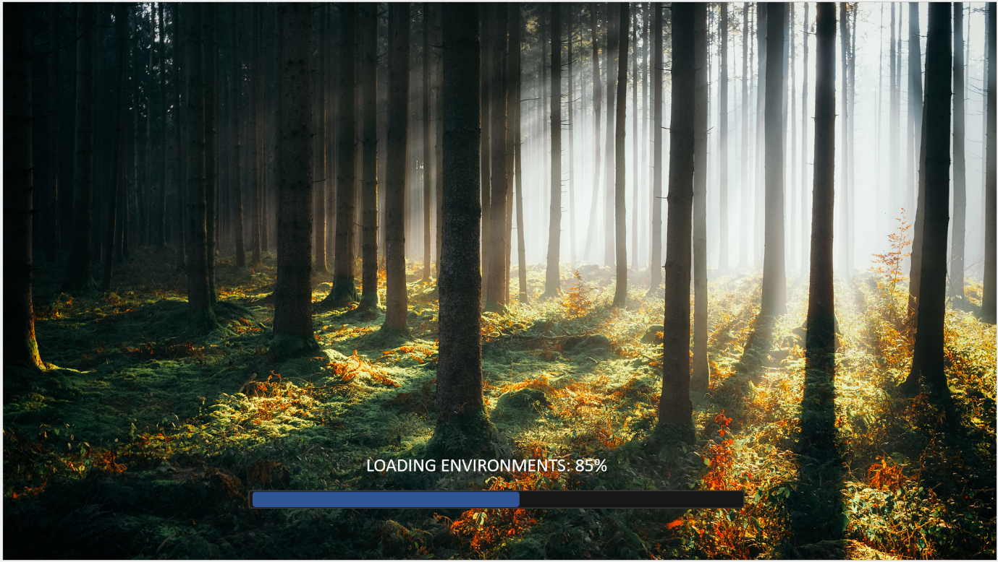

**Loading Screen 2:**

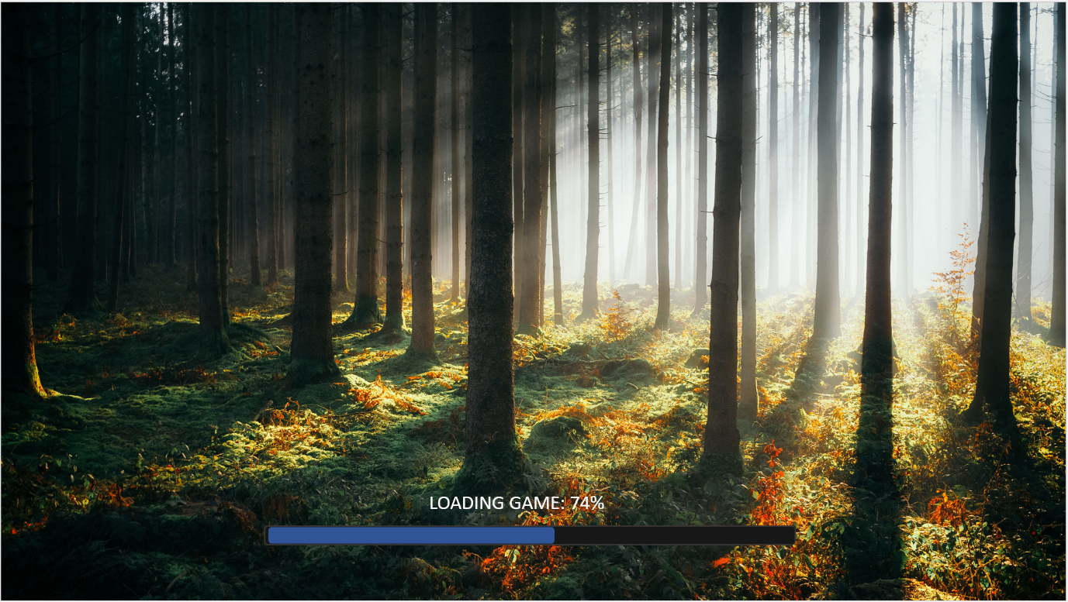

The next screen the user will see is the Start Menu screen. This screen will be the main navigation screen for the game in which the user will have three options. A “PLAY” button and load into the environment, a button to access the “OPTIONS”, and a “LEAVE GAME” button where the user can exit the application.

The start Menu will have a live background. This will consist of a scene created from the game assets with trees and plants along with a red squirrel character model from the game in the background. The squirrel will be animated.

**Start Menu:**

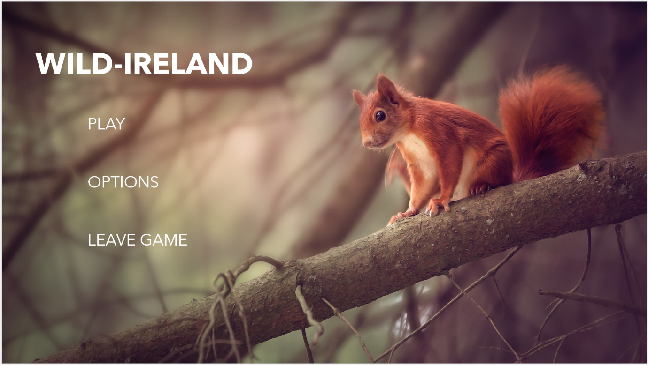

The next screen shows the “OPTIONS” screen when the button is clicked. This will use the same background and layout style as the start menu. The “OPTIONS” menu consists of a volume adjuster and an image of the controls The volume adjuster will allow the user to turn down the volume and the controls will show the control for the game.

**Options Screen:**

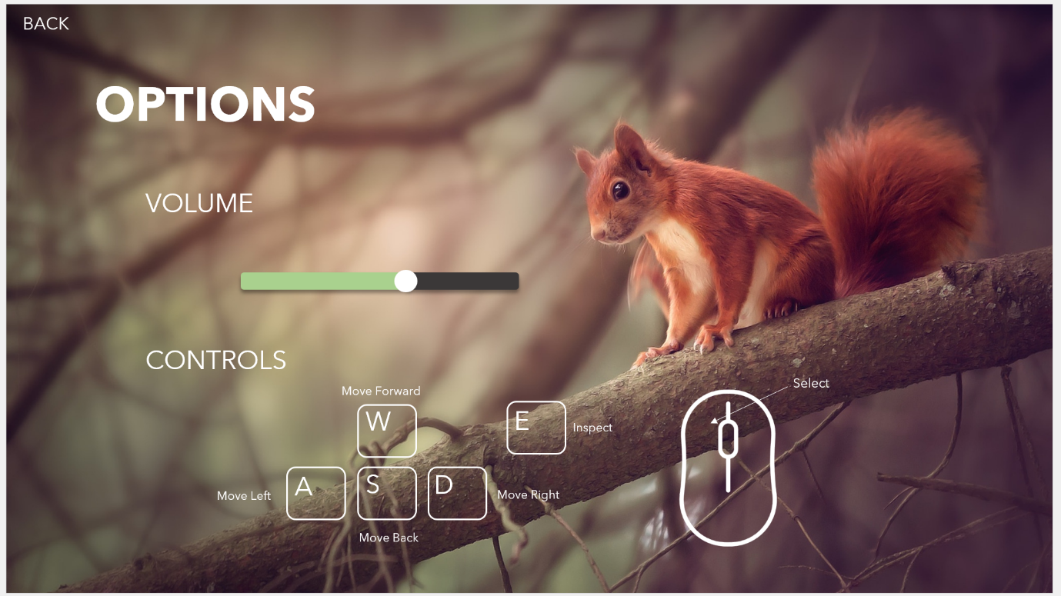

**3.5.2. Use Cases**

There are many use cases for this project. Shown below are the use cases for each feature of the game, the first use case shown will be the main use case diagram exploring all the features briefly, followed by each feature explained in more detail using use case scenarios.

(Using Creately.com)

**Use Case Diagram:**

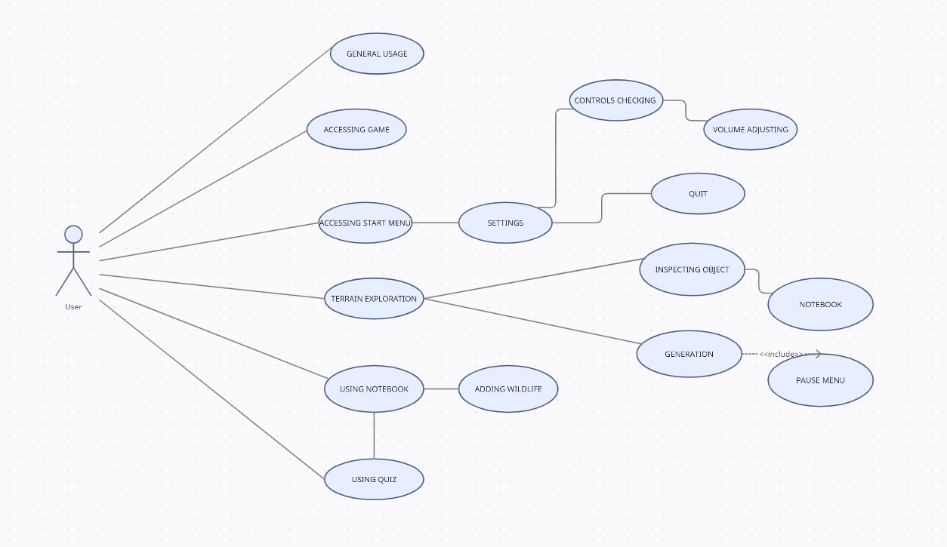

**Figure35-Use Case Diagram**

**Use Case Scenarios**

|  |  |  |  |  |
| --- | --- | --- | --- | --- |
| **USE CASE** | | **1** | **General Usage of Wild-Ireland** | |
| **Description of Goal in Context** | | **Navigating through application. Briefly looking at each feature. Use game as if user for first time to get all requirements.** | | |
| **Post Conditions, Success End Condition** | | **System will work well. Each feature works successfully with no errors.** | | |
| **Main Flow:** | | | | |
| **Step** | **Action** | | | **Alternate** |
| **1.1** | **Download Game** | | | **E or EF** |
| **1.2** | **Launch Game** | | |  |
| **1.3** | **View Loading Screen** | | |  |
| **1.4** | **View Start menu** | | |  |
| **1.5** | **Select Settings** | | |  |
| **1.6** | **Adjust Volume** | | |  |
| **1.7** | **Look at Controls** | | |  |
| **1.8** | **Select back** | | |  |
| **1.9** | **Select Play** | | | **E or EF** |
| **1.10** | **View Cutscene** | | |  |
| **1.11** | **Walk Around Terrain** | | |  |
| **1.12** | **Inspect Animal or Plant (wildlife)** | | | **E or EF** |
| **1.13** | **View Notebook** | | |  |
| **1.14** | **View Video** | | |  |
| **1.15** | **Start Quiz** | | | **E or EF** |
| **1.16** | **Add Animal to Notebook (Database)** | | |  |
| **1.17** | **Exit Notebook** | | |  |
| **1.18** | **View Pause Menu** | | |  |
| **1.19** | **Select Leave Game** | | |  |
| **1.20** | **Select Quit in Start menu** | | |  |
|  | | | | |
| **EXCEPTIONS or ERROR Flow Description** | | | | |
| **Step** | **Branching Action** | | |  |
| **1.1.1** | **Download Failed due to users memory full.**  **User Clears memory and retrys download.** | | |  |
| **1.9.1** | **Game not loading in. Cutscene having trouble playing**  **Error message shown, user exits game and restarts.** | | |  |
| **1.12.1** | **Inspect prompt not showing.**  **User moves closer or tries other animal.** | | |  |
| **1.15.1** | **Quiz not showing questions**  **Error message displayed and user restarts quiz.** | | |  |
|  | | | | |
|  | | | | |

|  |  |  |  |  |
| --- | --- | --- | --- | --- |
| **USE CASE** | | **2** | **Accessing Game** | |
| **Description of Goal in Context** | | **User will be able to download game, Install the game on their computer. Launch the game.** | | |
| **Post Conditions, Success End Condition** | | **Download goes smoothly. Each feature works successfully with no errors.** | | |
| **Main Flow:** | | | | |
| **Step** | **Action** | | | **Alternate** |
| **2.1** | **Go to download link** | | | **E or EF** |
| **2.2** | **Click downlload link** | | |  |
| **2.3** | **Download Game** | | | **E or EF** |
| **2.4** | **Install game** | | |  |
| **2.5** | **Click icon** | | |  |
| **2.6** | **Launch Game** | | |  |
| **2.7** | **Load into game** | | | **E or EF** |
| **2.8** | **View Start Menu** | | |  |
|  | | | | |
| **EXCEPTIONS or ERROR Flow Description** | | | | |
| **Step** | **Branching Action** | | |  |
| **2.1.1** | **Users PC does not meet game requirements**  **Access on different computer.** | | |  |
| **2.3.1** | **Memory Full.**  **Delete data and retry download.** | | |  |
| **2.7.1** | **Error loading into game.**  **Restart game and try loading in again.** | | |  |

|  |  |  |  |  |
| --- | --- | --- | --- | --- |
| **USE CASE** | | **3** | **Using Start Menu** | |
| **Description of Goal in Context** | | **User will be able navigate through menu features. All features will work successfully.** | | |
| **Post Conditions, Success End Condition** | | **Navigation goes smoothly. Successful with no errors.** | | |
| **Main Flow:** | | | | |
| **Step** | **Action** | | | **Alternate** |
| **3.1** | **Launch Game** | | |  |
| **3.2** | **View start menu** | | |  |
| **3.3** | **Click options** | | |  |
| **3.4** | **Click controls** | | |  |
| **3.5** | **View controls** | | | **E or EF** |
| **3.6** | **Press back** | | |  |
| **3.7** | **Click volume** | | | **E or EF** |
| **3.8** | **Adjust volume** | | |  |
| **3.9** | **Press back** | | |  |
| **3.10** | **Press start game** | | |  |
| **3.11** | **Press quit game** | | |  |
|  | | | | |
| **EXCEPTIONS or ERROR Flow Description** | | | | |
| **Step** | **Branching Action** | | |  |
| **3.5.1** | **Controls don’t match**  **Change controls.** | | |  |
| **3.7.1** | **Volume on wrong settings** | | |  |

|  |  |  |  |  |
| --- | --- | --- | --- | --- |
| **USE CASE** | | **4** | **Exploring Terrain/Environment** | |
| **Description of Goal in Context** | | **User will be able navigate/move through environment. All features will work successfully.** | | |
| **Post Conditions, Success End Condition** | | **Exploration goes smoothly. Successful with no errors. Inspecting, generation, notebook, Pause Menu.** | | |
| **Main Flow:** | | | | |
| **Step** | **Action** | | | **Alternate** |
| **4.1** | **Press start game** | | |  |
| **4.2** | **Load into environment** | | | **E or EF** |
| **4.3** | **Move throughout terrain** | | |  |
| **4.4** | **Find wildlife** | | |  |
| **4.5** | **Click prompt** | | |  |
| **4.6** | **Inspect animal/plant** | | |  |
| **4.7** | **View notebook** | | |  |
| **4.8** | **View information** | | |  |
| **4.9** | **Press back** | | |  |
| **4.10** | **Explore more** | | |  |
| **4.11** | **Press save** | | | **E or EF** |
| **4.12** | **Inspect more objects** | | |  |
| **4.13** | **Interact with animal AI** | | |  |
| **4.14** | **Press Pause Menu** | | |  |
| **4.15** | **Select exit to main menu** | | |  |
|  | | | | |
| **EXCEPTIONS or ERROR Flow Description** | | | | |
| **Step** | **Branching Action** | | |  |
| **4.2.1** | **Environment Fails to generate**  **Make procedural scripts more efficient** | | |  |
| **4.11.1** | **Game fails to save.**  **Error message Prompts.** | | |  |

|  |  |  |  |  |
| --- | --- | --- | --- | --- |
| **USE CASE** | | **5** | **Using Notebook** | |
| **Description of Goal in Context** | | **User will be able to access information on the notebook. All features will work successfully.** | | |
| **Post Conditions, Success End Condition** | | **Notebook feature are displayed and functional. Successful with no errors. Videos, paragraphs, pictures, Quiz, exit, add feature.** | | |
| **Main Flow:** | | | | |
| **Step** | **Action** | | | **Alternate** |
| **5.1** | **Press button for Notebook** | | |  |
| **5.2** | **View info on wildlife** | | |  |
| **5.3** | **Read text** | | |  |
| **5.4** | **View Pictures** | | |  |
| **5.5** | **Watch videos** | | | **E or EF** |
| **5.6** | **Add species to notebook/database** | | |  |
| **5.7** | **Succesfully added prompt** | | | **E or EF** |
| **5.8** | **Click quiz** | | |  |
| **5.9** | **Partake in quiz** | | |  |
| **5.10** | **Press done** | | |  |
| **5.11** | **Press exit notebook** | | |  |
| **5.12** | **Continue exploring** | | |  |
|  | | | | |
| **EXCEPTIONS or ERROR Flow Description** | | | | |
| **Step** | **Branching Action** | | |  |
| **5.5.1** | **Videos wont load.**  **Error message displayed.** | | |  |
| **5.7.1** | **Failed to add to database.**  **Animal not added.**  **Displays error prompt to retry.** | | |  |

|  |  |  |  |  |
| --- | --- | --- | --- | --- |
| **USE CASE** | | **6** | **Using Quiz** | |
| **Description of Goal in Context** | | **User will be able to access quiz in the notebook and test themselves on the knowledge they have learnt. All features will work successfully.** | | |
| **Post Conditions, Success End Condition** | | **Notebook feature are displayed and quiz is functional with no errors.. Successful with no errors. Answer questions , display score, re-take quiz.** | | |
| **Main Flow:** | | | | |
| **Step** | **Action** | | | **Alternate** |
| **6.1** | **Press button for Notebook** | | |  |
| **6.2** | **Press quiz button** | | |  |
| **6.3** | **Accessing quiz** | | |  |
| **6.4** | **Start quiz** | | |  |
| **6.5** | **Answer questions** | | | **E or EF** |
| **6.6** | **Tick boxes** | | |  |
| **6.7** | **Click next question** | | |  |
| **6.8** | **Submit quiz** | | | **E or EF** |
| **6.9** | **Prompt message** | | |  |
| **6.10** | **Press done** | | |  |
| **6.11** | **View score** | | |  |
| **6.12** | **Re-take quiz** | | |  |
| **6.13** | **Click done** | | |  |
| **6.14** | **Exit quiz** | | |  |
| **6.15** | **Return to game.** | | |  |
|  | | | | |
| **EXCEPTIONS or ERROR Flow Description** | | | | |
| **Step** | **Branching Action** | | |  |
| **6.5.1** | **Questions not appearing**  **Restart quiz,** | | |  |
| **6.8.1** | **Quiz not submitting.**  **Results not appearing.**  **Error message shown.**  **Retry.** | | |  |

|  |  |  |  |  |
| --- | --- | --- | --- | --- |
| **USE CASE** | | **7** | **Working Database** | |
| **Description of Goal in Context** | | **User will be able to successfully add animals to notebook database and save the game with working database using Easy-Save.** | | |
| **Post Conditions, Success End Condition** | | **Everything will be added to the database Easy-Save successfully with no errors.** | | |
| **Main Flow:** | | | | |
| **Step** | **Action** | | | **Alternate** |
| **7.1** |  | | |  |
| **7.2** |  | | |  |
| **7.3** |  | | |  |
| **7.4** |  | | |  |
| **7.5** |  | | | **E or EF** |
| **7.6** |  | | |  |
| **7.7** |  | | |  |
| **7.8** |  | | | **E or EF** |
| **7.9** |  | | |  |
| **7.10** |  | | |  |
| **7.11** |  | | |  |
| **7.12** |  | | |  |
| **7.13** |  | | |  |
| **7.14** |  | | |  |
| **7.15** |  | | |  |
|  | | | | |
| **EXCEPTIONS or ERROR Flow Description** | | | | |
| **Step** | **Branching Action** | | |  |
| **7.5.1** |  | | |  |
| **7.8.1** |  | | |  |

**3.6. Back-End**

**\*Database* for save game feature and adding animals to notebook – Easy Save.**

**\*How the database is going to work exactly.\***

**\*inventory, saveing and add animals.\***

For the back end of this system, the data layer is used for data storage so the game can store, save and load data. The database system will be used so that the end-user can save their game and keep the progress made. The database will also be used to create the inventory system that is accessible through the notebook feature.

*Describe what and how you are going to do it.*

**3.7. System Design**

**3.7.1. Art**

For the moment, a low poly art style will be used. This will save time when creatin models. However, if there is enough time, a higher quality more realistic style of modelling and art will be created and used throughout the game. The colours used will match the colours of the forests and wildlife in Ireland. Below are sample real-life pictures taken in Wicklow, Ireland.

**\*Pictures here\***

**3.7.2. Models**

In Ireland there is lots of wildlife. In this project only a handful of animals, plant, trees, and other objects will be chosen to be put in the landscape. This is because attempting to create too many models will be too time consuming. The chosen species will be discussed below and how they will be designed.

**Animals**

This project is based on wildlife in Ireland so all animals and wildlife will be chosen that is native to Ireland. Below are the animals that will be in the game and the different plants and other wildlife. The pictures that the animals and plants will be modelled after are also shown.

**Red Deer**

The red deer is a large deer species. It is very common and is found all over Ireland.

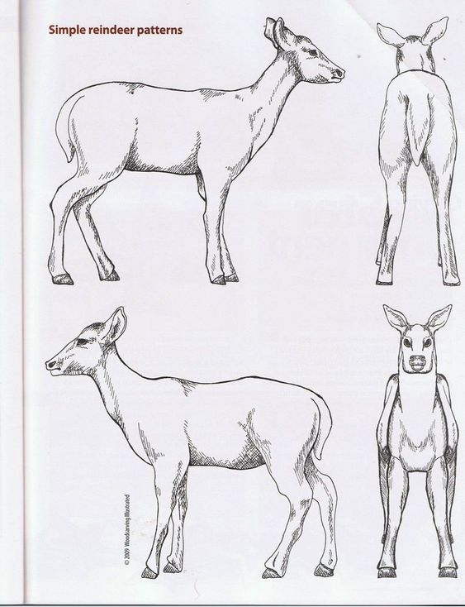

**Red Foxes**

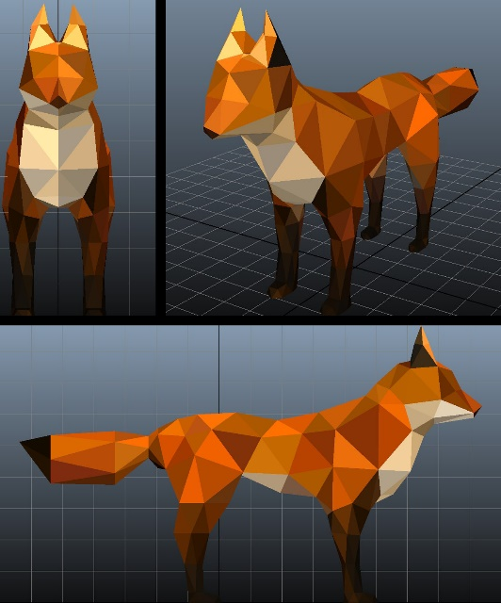 

**Red Squirrel**

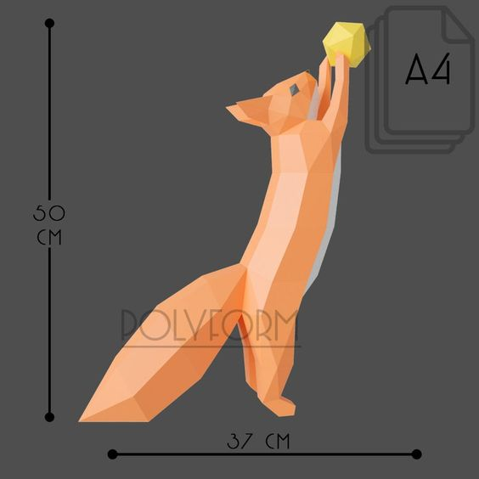 



**Irish Badger**

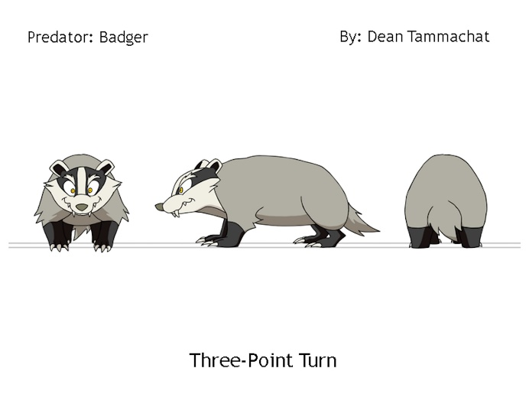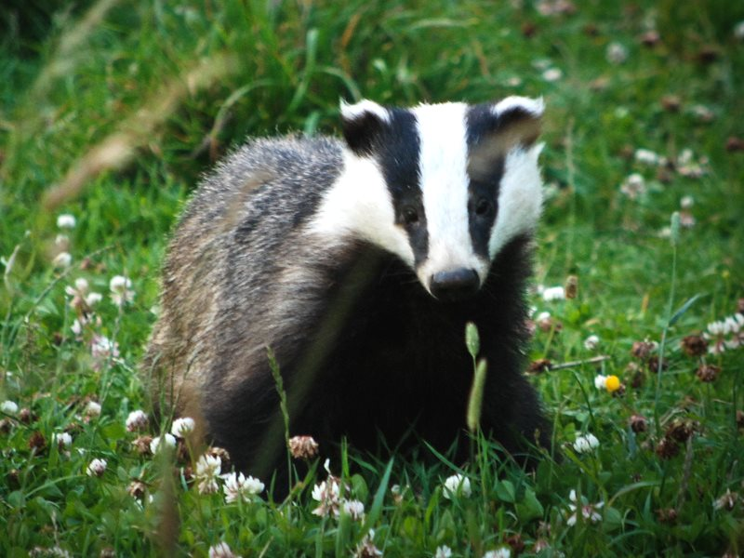

**Common Frog**

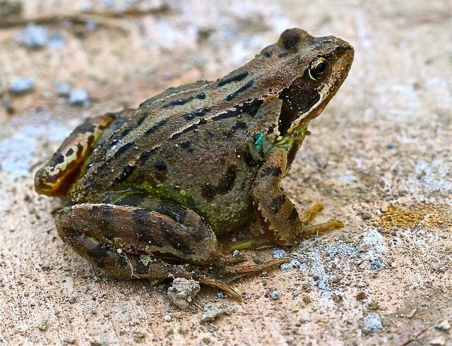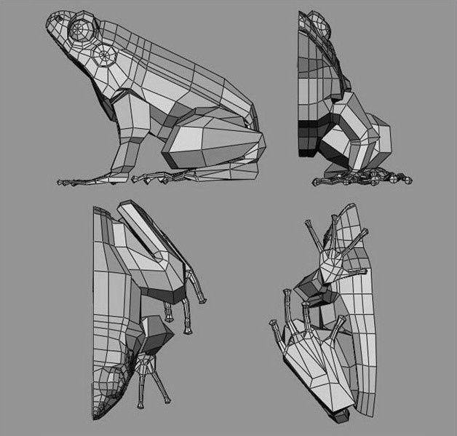

**Trees / Plants**

Willow Tree, Sycamore, Ash, Pine, Oak, Red Wood, Silver Birch. Various Bushes, Flowers, Ferns, Nettles etc.

**Rocks / Sticks / Debris**

Boulders, Pebbles, Rocks, Sticks, Pine Needles, Twigs, Dust, Puddles, Water, Grass etc.

**3.7.3. Audio**

**\*explain what sounds/music, animal sounds etc\***

In this game, the audio will have an important part to play as it allows the user to be immersed in the game and listen to all the different sounds you would hear out in the wild in Ireland today. There will be sound effect for the animals, wildlife and a soundtrack for the game which will play in the background.

**3.8. Conclusions**

In this section, we explore and discuss the different aspects of design. It first looks at version control and setup of the project followed by the design methodology where it discusses the use of GitHub and the chosen ADDIE Model. It then talks about the system architecture along with the system Requirements. After this, the early prototypes are shown by presenting them in picture form. Use case scenarios are thoroughly examined looking at the different outcomes for this game and finally the System Design in relation to models, art style and audio are explained.

**4. Development**

**4.1. Introduction**

In this section, the overall approach taken in the system development for this project is discussed in detail alongside the prototype. The development will discuss many features such as the terrain generation, the wildlife AI, asset modelling, UI creation, animation, coding methods and educational techniques. The player movements and components along with all the necessary game components such as audio and how the game will be made available to the user. All development of usability features will be outlined.

**4.2. Prototype**

**5. Testing and Evaluation**

**5.1. Introduction**

This section will outline the testing methods used in this project during its development. GitHub Version control will be discussed along with a White and Black Box testing plan. Tests groups will be made for users to try out the system and find errors. The final part of this section will discuss the evaluation of the project, outlining the issues and feedback.

**5.2. Plan for Testing**

For the duration of this project, tests will be run frequently. This will be done through Unity to make sure the game is functioning properly. As discussed in the Design section, the use of GitHub will help with testing so that if there are errors with the system, having backups will be useful so that the system can be returned to its original state before the errors were encountered.

**White Box Testing**

White box testing allows the tester to examine the structure, design, and coding of a chosen system. This method will be used to improve the overall usability experience for the user and increase the design strength, whilst finding smaller errors throughout the application as well.

This project will involve a lot of trial and error regarding the development process. Each feature will be tested until they are suitable to be shown to a third-party user such as someone outside the project or a testing group. When errors arise, they will be recorded to be later solved.

**Black Box Testing**

Black-box testing allows for scenarios or use cases to be tested where the system or software has errors. An example of these scenario errors would be a user inputting something like a username with the wrong syntax and the application won’t output an error message. This will be classified as an error for black box testing. An example in this project would be if the user tried to inspect an animal and the wrong animal is shown in the user’s notebook, or the animal isn’t shown at all.

For this system, user testing will be the most efficient way to outline the potential faults in the game. Group testing will be organized where possible end users will use the application and look for potential errors. Any issues identified in group testing and testing will single end users will be recorded either on a computer or by video if the test is conducted via an online call. Forms or surveys will be created and used to record feedback as well.

The final testing phase will consist of an alpha version of the game made available to play and be tested. This will identify the final error so that the finishing touches can be applied.

**Test Plan Table**

|  |  |  |  |
| --- | --- | --- | --- |
| **Test No.** | **Test Description** | **Expected Outcome** | **Pass? - Checkmark with solid fill/Close with solid fill** |
| **1** | Does the game successfully download? | The game will download to the user’s computer. |  |
| **2** | Does the game launch when selected? |  |  |
| **3** | Does the loading screen appear? |  |  |
| **4** | Does the Game take long to load? |  |  |
| **5** | Does the Start menu appear? |  |  |
| **6** | Is the music playing? |  |  |
| **7** | Does the settings button work? |  |  |
| **8** | Can you adjust the volume? |  |  |
| **9** | Can you View the controls? |  |  |
| **10** | Does the back button work? |  |  |
| **11** | Does the quit button work? |  |  |
| **12** | Does the start game button work |  |  |
| **13** | Does the game load quickly? |  |  |
| **14** | Does the Game work when loaded? |  |  |
| **15** | Is the User allowed to manoeuvre? |  |  |
| **16** | Does the Controls match the default? |  |  |
| **17** | Are the objects spawned in? |  |  |
| **18** | Does the game look as intend? |  |  |
| **19** | Can you interact with animals? |  |  |
| **20** | Can you interact with wildlife? |  |  |
| **21** | Does the AI react to user? |  |  |
| **22** | Does the AI work? |  |  |
| **23** | Is the terrain Generated? |  |  |
| **24** | Is The environment generated? |  |  |
| **25** | Does the notebook work? |  |  |
| **26** | Does the Database work when animal added? |  |  |
| **27** | Does the Quiz work? |  |  |
| **28** | Do all the Action buttons work? |  |  |
| **29** | Does the settings menu work? |  |  |
| **30** | Do the buttons in the menu Allow you to adjust volume, view controls and quit. |  |  |
| **31** | Does the save feature work? |  |  |
| **32** | Does the Resume button work? |  |  |
| **33** | Are there any glitches? |  |  |
| **34** | Are there any performance issues? |  |  |
| **35** | Is the game running slow? |  |  |
| **36** | Are the error messages displayed? |  |  |
| **37** | Does the information display in notebook? |  |  |
| **38** | Does the video Play in Notebook? |  |  |
| **39** | Can you exit the Notebook? |  |  |
| **40** | Does the inspect prompt show for wildlife? |  |  |
| **41** | Is the in-game music playing? |  |  |
| **42** | Is the sound effect/Audio working? |  |  |
| **43** | Are all animations being executed? |  |  |

**5.3. Plan for Evaluation**

In this project the evaluation is a high priority, this is because the user experience when using this system is extremely important. The application should be easy to use, and not require the user to be wondering how to use it or not know what the application is about. When this system is evaluated by a variety of end-users, the developer and possible industry professionals, it will mean that the system has been evaluated in many ways so the standard of usability will be at its strongest. This section will outline what approach was taken to evaluate the system and the metrics used as well.

**5.4. Conclusions**

This section discussed the testing and evaluation of this project. The testing discussed was white box and black box testing alongside using GitHub for backups and end-user testing. The evaluation consists of feedback from lots of potential end-users which was considered and used to change and successfully complete the system development.

**6. Issues and Future Work**

**6.1. Introduction**

This Final section of the project will reflect on the entire system. It will discuss possible future work for the project and then conclude the project by talking about its key points.

**6.2. Issues and Risks**

In this project there a several challenges or issues that are not yet resolved. These issues are as follows:

* Low amounts of knowledge in Rigging in Blender
* Struggling to find way of using LIDAR technology
* Lack of Experience with coding animal AI.
* No experience in using the Easy Save Database.
* Lack of time to Organise testing groups.

To solve these issues the following actions will be taken:

* Complete research in rigging, use tutorials and look at online courses to improve knowledge.
* If unable to acquire phone that will work with LIDAR, Model the terrain assets in blender instead.
* Undergo research for AI, watch tutorials and look at academic papers.
* Practice using database and watch tutorial on how to use it. Then, read the guidelines.
* Set aside time to organize test groups and make sure they are as efficient as possible.

Next, the risks will be discussed. They are as follows:

* Only able to work on project on PC mostly from home as laptop isn’t very powerful.
* Workload could be too much, as system is feature heavy.
* Not meeting required deadline.
* Prototype not fully functioning for Demo.
* Research links might not be reliable sources of information.

To solve these risks the following actions will be considered:

* Work on more complex programs such as Unity and Blender from home. Work on applications such as word and GitHub on laptop.
* Reduce number of features that might contribute to a work overload.
* Manage time efficiently by completing work within plenty of time.
* Make sure testing phases is completed to allow for a fully functioning prototype.
* Don’t use Wikipedia as a source or information that might be unreliable.

**6.3. Plans and Future Work**

Plans for future work on this project will be shown using a GANTT chart. this chart will outline the plans for this project and show specific dates and topics to be completed. When more progress is made on this project, a second GANTT chart will be used if any changes are made. By the end of this project the two GANTT chart will be compared. This will show the differences between the two and how the plans differ from the final product.

By the end of the project features that could have been implemented into the project will be discussed, along with possible game mechanics that might improve the game by using the feedback given by the end-users for this project. Features such as the procedural generation, AI, UI, Modelling will be discussed as to whether they should be improved or changed.

**6.3.1 GANTT Charts**

**6.4. Conclusions**

Below are the conclusions for this project discussing the various sections of the project in which the major key points will be outlined.

**6.4.1. Literature Review**

**6.4.1. Design**

**6.4.3. Development**

**6.4.4. Testing and evaluation**

**6.4.5. Issues**

**6.4.6. Final Reflections**

**Bibliography**